Secondary Standards
# Source: AI Source: Provided by: [Data Path: Persons Table -> ID Column: 1, Name_En Column: Motasem Essam] -> From: [ChatGPT] on [7/17/2026]
Secondary Standards are measurement standards that are calibrated directly against primary standards. They possess a high level of accuracy but are slightly less accurate than primary standards. Secondary standards are used to calibrate reference standards, working standards, and high-precision measuring instruments.
They act as the essential link between primary standards and the standards used for routine calibration and measurement.

Definition
# Source: AI Source: Provided by: [Data Path: Persons Table -> ID Column: 1, Name_En Column: Motasem Essam] -> From: [ChatGPT] on [7/17/2026]
A Secondary Standard is a measurement standard whose value is determined by comparison with a primary standard and which is used for calibrating lower-level standards.
Secondary standards provide a practical means of transferring the accuracy of primary standards to laboratories and industry.

Purpose
# Source: AI Source: Provided by: [Data Path: Persons Table -> ID Column: 1, Name_En Column: Motasem Essam] -> From: [ChatGPT] on [7/17/2026]
Secondary standards are used to:
- Transfer measurement accuracy from primary standards.
- Calibrate reference standards.
- Calibrate working standards.
- Support calibration laboratories.
- Maintain measurement traceability.
- Reduce wear on primary standards.

Characteristics
# Source: AI Source: Provided by: [Data Path: Persons Table -> ID Column: 1, Name_En Column: Motasem Essam] -> From: [ChatGPT] on [7/17/2026]
Secondary standards are:
- Highly accurate.
- Calibrated directly against primary standards.
- Traceable to the International System of Units (SI).
- More frequently used than primary standards.
- Easier to access and maintain.
- Periodically recalibrated.

Position in the Measurement Hierarchy
# Source: AI Source: Provided by: [Data Path: Persons Table -> ID Column: 1, Name_En Column: Motasem Essam] -> From: [ChatGPT] on [7/17/2026]
Secondary standards occupy the third level of the measurement hierarchy.
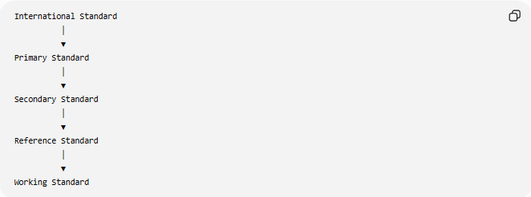
International Standard
│
▼
Primary Standard
│
▼
Secondary Standard
│
▼
Reference Standard
│
▼
Working Standard

How Secondary Standards Are Established
# Source: AI Source: Provided by: [Data Path: Persons Table -> ID Column: 1, Name_En Column: Motasem Essam] -> From: [ChatGPT] on [7/17/2026]
The accuracy of a secondary standard is obtained by calibration against a primary standard.
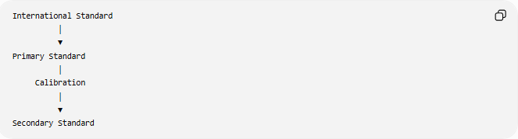
International Standard
│
▼
Primary Standard
│
Calibration
│
▼
Secondary Standard

Functions of Secondary Standards
# Source: AI Source: Provided by: [Data Path: Persons Table -> ID Column: 1, Name_En Column: Motasem Essam] -> From: [ChatGPT] on [7/17/2026]
Secondary standards are used to:
- Calibrate reference standards.
- Calibrate working standards.
- Verify laboratory measurements.
- Maintain traceability.
- Support industrial calibration.
- Reduce the direct use of primary standards.

Examples of Secondary Standards
# Source: AI Source: Provided by: [Data Path: Persons Table -> ID Column: 1, Name_En Column: Motasem Essam] -> From: [ChatGPT] on [7/17/2026]
Length
A precision gauge block set calibrated against a national primary length standard.

Mass
A laboratory calibration weight whose mass has been certified by comparison with a primary mass standard.

Time
A high-precision laboratory clock calibrated against a national atomic clock.

Temperature
A precision thermometer calibrated using a primary temperature standard.

Pressure
A precision pressure calibrator certified against a national primary pressure standard.

Electrical Measurements
- Precision voltage reference calibrated against a Josephson voltage standard.
- Precision resistance standard calibrated against a quantum Hall resistance standard.

Traceability
# Source: AI Source: Provided by: [Data Path: Persons Table -> ID Column: 1, Name_En Column: Motasem Essam] -> From: [ChatGPT] on [7/17/2026]
Secondary standards maintain traceability by linking lower-level standards to primary standards.
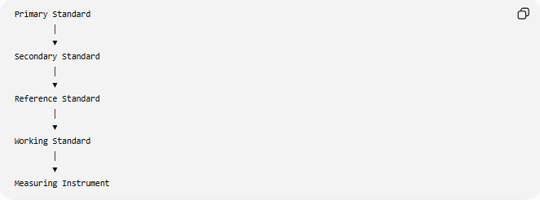
Primary Standard
│
▼
Secondary Standard
│
▼
Reference Standard
│
▼
Working Standard
│
▼
Measuring Instrument

Calibration
# Source: AI Source: Provided by: [Data Path: Persons Table -> ID Column: 1, Name_En Column: Motasem Essam] -> From: [ChatGPT] on [7/17/2026]
Secondary standards require periodic recalibration.
Calibration process:
- Compare the secondary standard with a primary standard.
- Determine any measurement error.
- Adjust or certify the standard.
- Document the calibration.
- Assign a calibration interval.

Advantages
# Source: AI Source: Provided by: [Data Path: Persons Table -> ID Column: 1, Name_En Column: Motasem Essam] -> From: [ChatGPT] on [7/17/2026]
Secondary standards:
- Maintain high measurement accuracy.
- Protect primary standards from excessive use.
- Support efficient calibration services.
- Reduce calibration costs.
- Improve accessibility for laboratories.
- Maintain measurement traceability.

Applications
# Source: AI Source: Provided by: [Data Path: Persons Table -> ID Column: 1, Name_En Column: Motasem Essam] -> From: [ChatGPT] on [7/17/2026]
Secondary standards are commonly used in:
- Calibration laboratories.
- Manufacturing.
- Engineering.
- Scientific research.
- Medical equipment calibration.
- Electronics.
- Aerospace.
- Industrial quality control.

Everyday Importance
# Source: AI Source: Provided by: [Data Path: Persons Table -> ID Column: 1, Name_En Column: Motasem Essam] -> From: [ChatGPT] on [7/17/2026]
Although not directly visible to the public, secondary standards help ensure:
- Accurate weighing scales.
- Correct fuel pump measurements.
- Reliable thermometers.
- Precise industrial manufacturing.
- Consistent laboratory testing.
- Proper calibration of measuring equipment.

Common Mistakes
# Source: AI Source: Provided by: [Data Path: Persons Table -> ID Column: 1, Name_En Column: Motasem Essam] -> From: [ChatGPT] on [7/17/2026]
- Confusing secondary standards with working standards.
- Assuming secondary standards have the same accuracy as primary standards.
- Using secondary standards without periodic recalibration.
- Ignoring traceability documentation.

Key Points
# Source: AI Source: Provided by: [Data Path: Persons Table -> ID Column: 1, Name_En Column: Motasem Essam] -> From: [ChatGPT] on [7/17/2026]
- Secondary standards are calibrated against primary standards.
- They provide high accuracy with greater practicality.
- They are used to calibrate reference and working standards.
- They maintain traceability to SI units through primary standards.
- They help preserve the integrity of primary standards by reducing their routine use.

Secondary Standards vs. Primary Standards
# Source: AI Source: Provided by: [Data Path: Persons Table -> ID Column: 1, Name_En Column: Motasem Essam] -> From: [ChatGPT] on [7/17/2026]
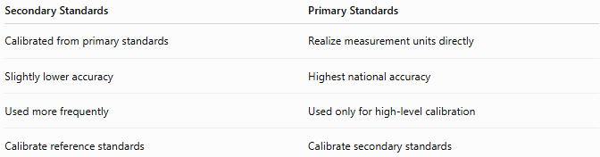
Secondary Standards | Primary Standards
Calibrated from primary standards | Realize measurement units directly
Slightly lower accuracy | Highest national accuracy
Used more frequently | Used only for high-level calibration
Calibrate reference standards | Calibrate secondary standards

Secondary Standards vs. Reference Standards
# Source: AI Source: Provided by: [Data Path: Persons Table -> ID Column: 1, Name_En Column: Motasem Essam] -> From: [ChatGPT] on [7/17/2026]
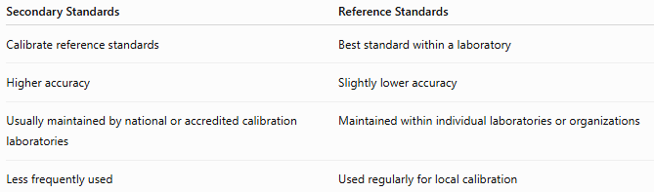
Secondary Standards | Reference Standards
Calibrate reference standards | Best standard within a laboratory
Higher accuracy | Slightly lower accuracy
Usually maintained by national or accredited calibration laboratories | Maintained within individual laboratories or organizations
Less frequently used | Used regularly for local calibration

Secondary Standards vs. Working Standards
# Source: AI Source: Provided by: [Data Path: Persons Table -> ID Column: 1, Name_En Column: Motasem Essam] -> From: [ChatGPT] on [7/17/2026]
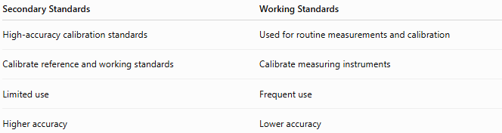
Secondary Standards | Working Standards
High-accuracy calibration standards | Used for routine measurements and calibration
Calibrate reference and working standards | Calibrate measuring instruments
Limited use | Frequent use
Higher accuracy | Lower accuracy

Conclusion
# Source: AI Source: Provided by: [Data Path: Persons Table -> ID Column: 1, Name_En Column: Motasem Essam] -> From: [ChatGPT] on [7/17/2026]
Secondary Standards are high-accuracy measurement standards calibrated directly against primary standards. They serve as the critical link between primary standards and the standards used in everyday calibration, maintaining measurement traceability while protecting primary standards from routine use. Widely employed in calibration laboratories, industry, engineering, and scientific research, secondary standards ensure that measurements remain accurate, consistent, and internationally traceable throughout the measurement hierarchy.

